[](https://www.google.cz/url?sa=i&url=https%3A%2F%2Fwww.promaminky.cz%2Fkreativni-dilna%2Fobrazky-omalovanky-299%2Fomalovanky-zelva-3989&psig=AOvVaw1FKlkrfNlc47KuYnKwSB7y&ust=1617094041572000&source=images&cd=vfe&ved=0CAIQjRxqFwoTCMii0pmP1e8CFQAAAAAdAAAAABAK)

[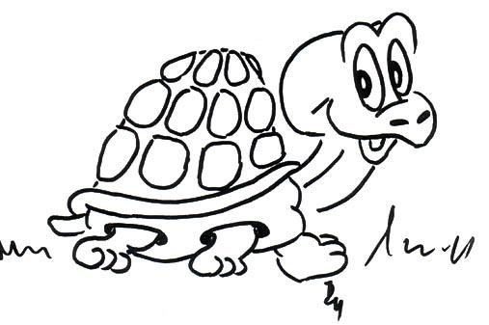](https://www.google.cz/url?sa=i&url=https%3A%2F%2Fwww.promaminky.cz%2Fkreativni-dilna%2Fobrazky-omalovanky-299%2Fomalovanky-zelva-3989&psig=AOvVaw1FKlkrfNlc47KuYnKwSB7y&ust=1617094041572000&source=images&cd=vfe&ved=0CAIQjRxqFwoTCMii0pmP1e8CFQAAAAAdAAAAABAD) 4

[](https://www.google.cz/url?sa=i&url=https%3A%2F%2Fpixers.cz%2Fnalepky%2Fmorska-zelva-omalovanky-65274028&psig=AOvVaw1FKlkrfNlc47KuYnKwSB7y&ust=1617094041572000&source=images&cd=vfe&ved=0CAIQjRxqFwoTCMii0pmP1e8CFQAAAAAdAAAAABAX)

[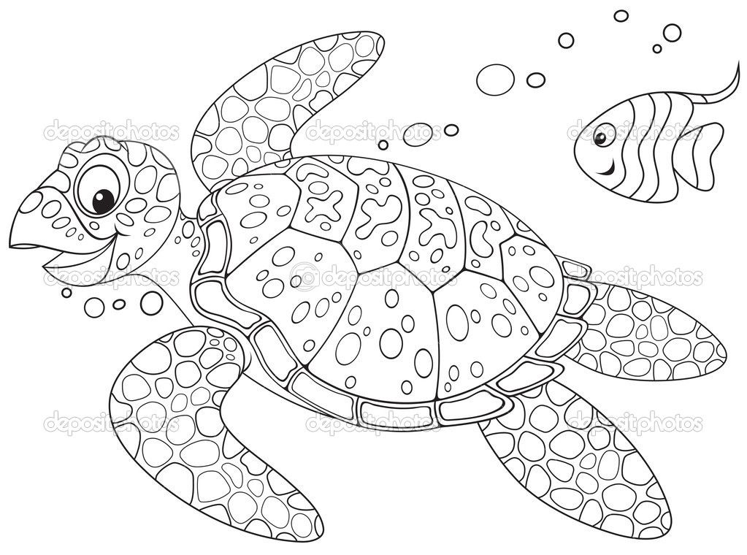](https://www.google.cz/url?sa=i&url=https%3A%2F%2Fcz.pinterest.com%2Fpin%2F492933121696874013%2F&psig=AOvVaw1IPad2c79XQqJSZRlUzAlF&ust=1617094226958000&source=images&cd=vfe&ved=0CAIQjRxqFwoTCMDc9_GP1e8CFQAAAAAdAAAAABAR)

[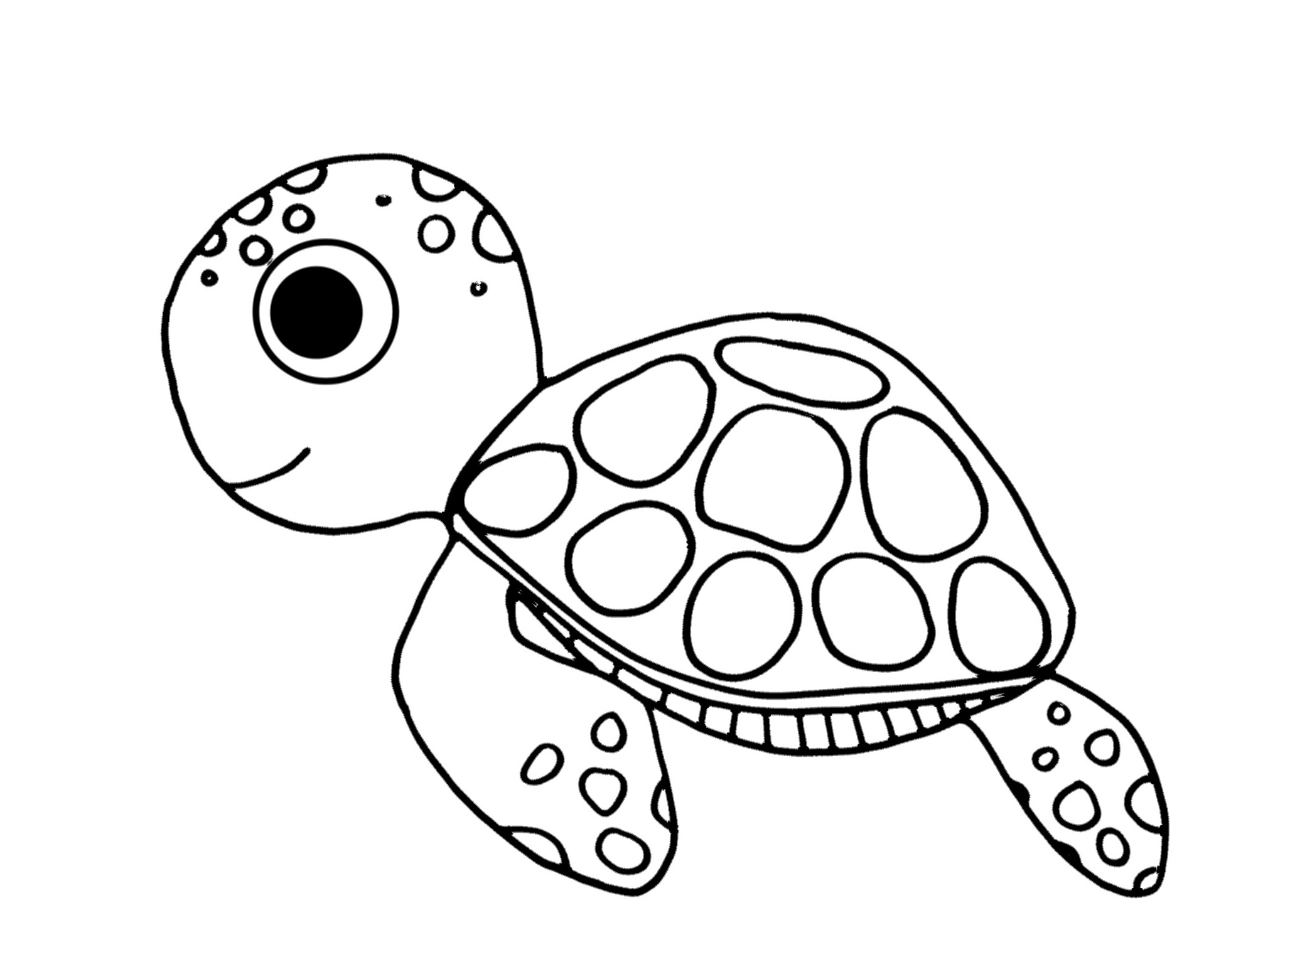](https://www.google.cz/url?sa=i&url=http%3A%2F%2Fm.i-creative.cz%2F2016%2F07%2F13%2Fhleda-se-dory-omalovanky%2F&psig=AOvVaw1IPad2c79XQqJSZRlUzAlF&ust=1617094226958000&source=images&cd=vfe&ved=0CAIQjRxqFwoTCMDc9_GP1e8CFQAAAAAdAAAAABAf)

[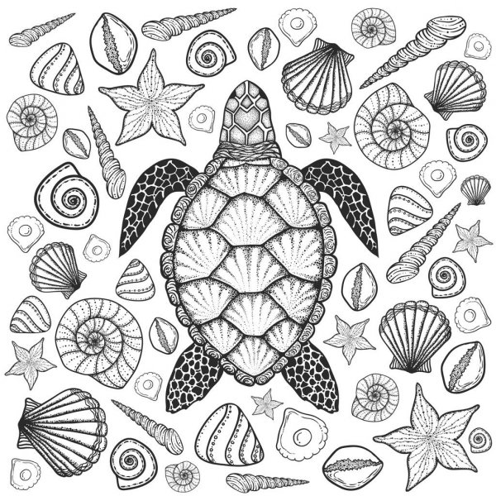](https://www.google.cz/url?sa=i&url=https%3A%2F%2Fcz.depositphotos.com%2Fvector-images%2Fkrun%25C3%25BD%25C5%2599e.html&psig=AOvVaw1IPad2c79XQqJSZRlUzAlF&ust=1617094226958000&source=images&cd=vfe&ved=0CAIQjRxqFwoTCMDc9_GP1e8CFQAAAAAdAAAAABAK)